**Year 12 Assessment Template – Creating a database-driven website – AS91892/3**

## Stage 1 – Relevant implications and conventions

Relevant implication 1: Identify a relevant implication that you need to consider. Describe what it is and explain why it is important that your final website meets this implication. You may use an implication that you used in the design standard.

Functionality: **Website functionality** is essentially what your **website** can do and how it works. It encompasses everything from the actions a user can perform to dynamic content and interactivity. This is import to my code because my web site wont work without it. I will address this by making my data base clear and understandable. I will also make it so it does what I want it to do, so I can create accounts like music and upload music.

Relevant implication 2: Identify a relevant implication that you need to consider. Describe what it is and explain why it is important that your final website meets this implication.

Privacy: Privacy will mean that all the stuff I put in to the data base should be protected. It means that hackers cant hack and and take peoples passwords and use them for bad. I need this in my data base so my users passwords and information wont be put at risk. I will implement this by running every ones passwards through a hash function so that there information will be stored safely in that data base.

Web design conventions: Identify some of the conventions you will follow (this will likely include using stylesheets, reusing code with php includes, file naming conventions, commenting)

I will use a css style sheet for formatting and making my wesite look nice. I will also reuses lots of my code, expusialy the php. I will also comment all my code to make it easier for when someone else would ever look at my code and I will also name my files clearly.

## Stage 2 – Establishing design of site and database and relevant implications

Site design: Include a screenshot here of the final design you came up with in the design standard. (It is okay if your design changes during the creation stage.)

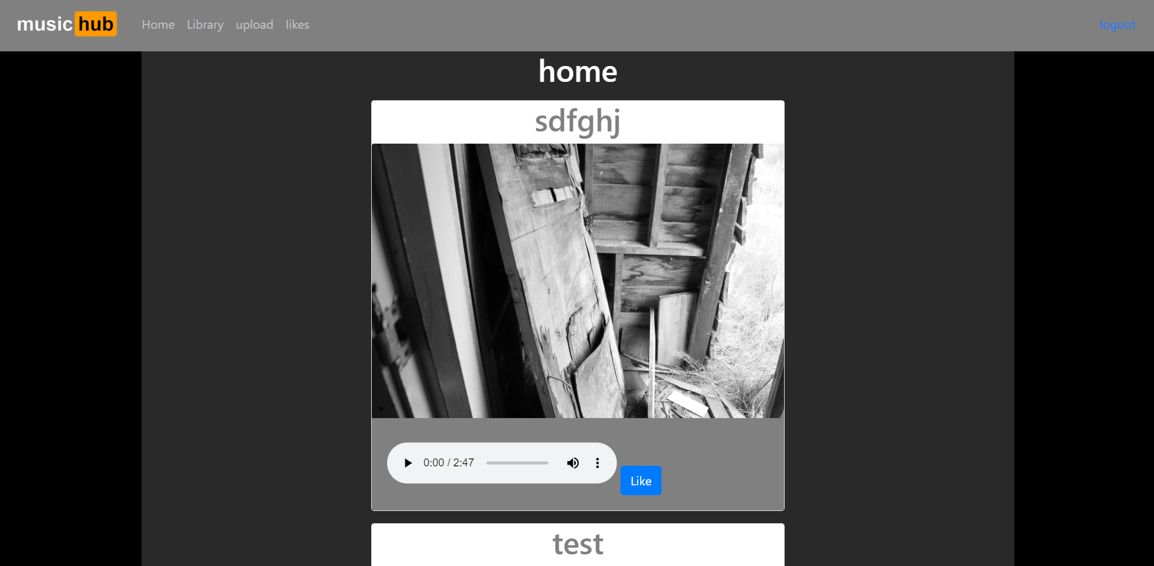

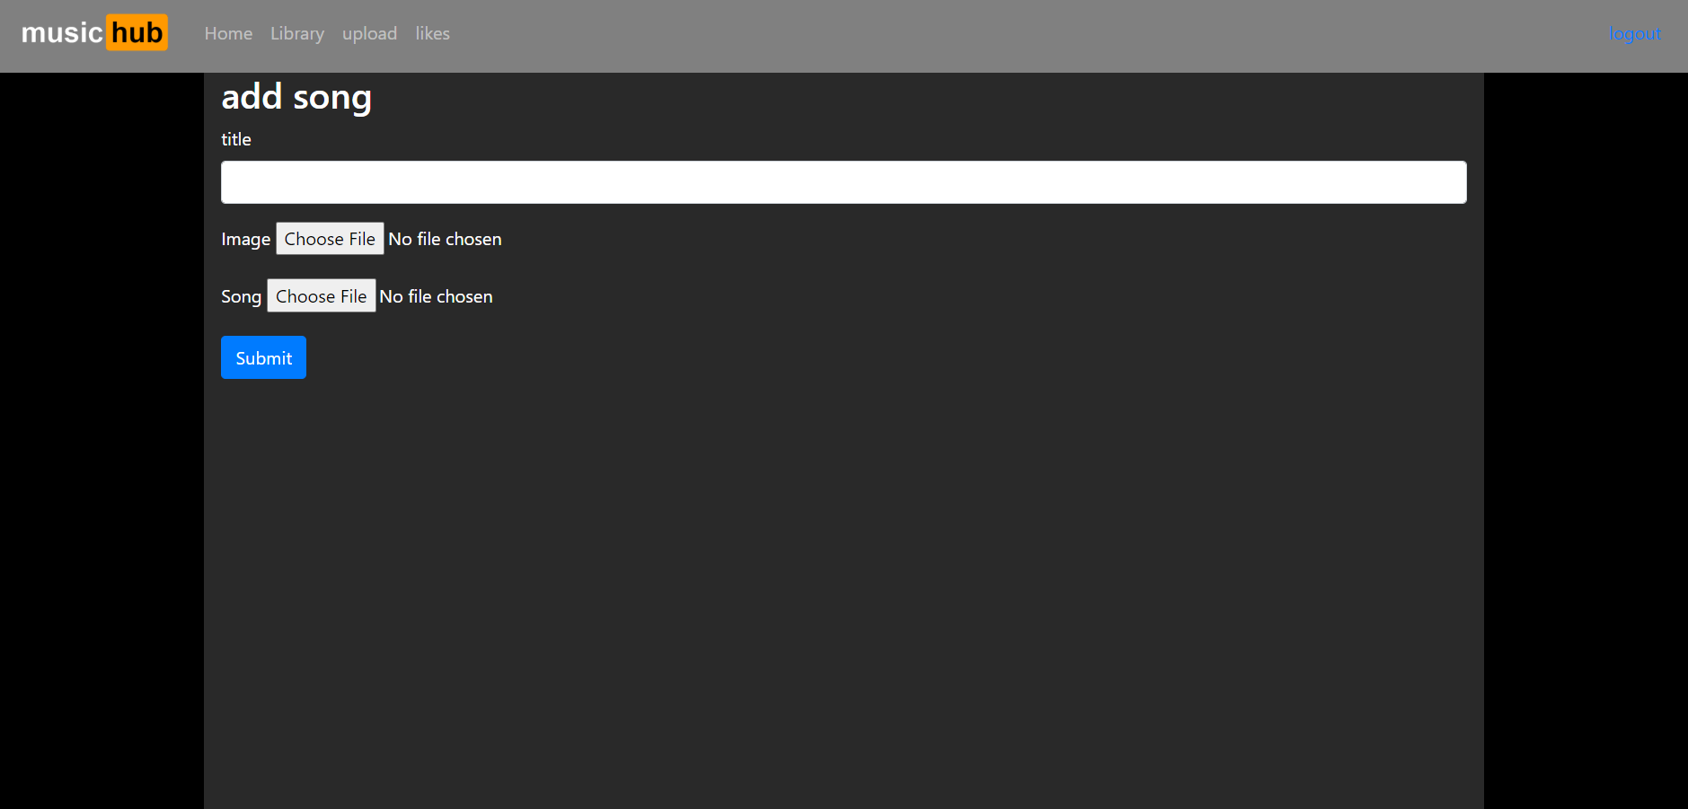

Database design: Fill in the tables below with the names of the tables, column names, data types and lengths.

|  |  |  |  |
| --- | --- | --- | --- |
| Table name:Likes | Enter name of table here | | |
| Column names | Data type | Length | Comment(s) |
| likeID | int | 5 | Ai will give the song they like a number |
| userID | int | 4 | To know what user liked the song |
| musicID | int | 3 | To Know what song the user has liked |
|  |  |  |  |
|  |  |  |  |

|  |  |  |  |
| --- | --- | --- | --- |
| Table name:music | Enter name of table here | | |
| Column names | Data type | Length | Comment(s) |
| musicID | int | 4 | Ai will give the music a number |
| title | varchar | 50 | Name of the song |
| filename | varchar | 300 | Filename of the song for the music player |
| userID | int | 4 | UserID of the user that uploaded the song. |
| image | varchar | 400 | Image filename to display with the song and title |

|  |  |  |  |
| --- | --- | --- | --- |
| Table name:users | Enteru name of table here | | |
| Column names | Data type | Length | Comment(s) |
| userID | int | 3 | AI will give the users a number |
| username | varchar | 30 | Storing the usernames |
| password | varchar | 100 | Storing hashed passwords |
|  |  |  |  |
|  |  |  |  |

(Add more tables if necessary)

Justification of database design: Explain why you have designed the database this way. i.e. Justify why you have used common keys across tables.

I set up my data base this way so I will be able to firstly create accounts. I will make it so I can create accounts and have their password hashed. I will also make it so the users can upload music with a title and image to go with it. I Also made it so you can like the songs and you will be able to see the songs they have liked.

## Stage 3 – Ongoing testing and development

In this stage you need to provide evidence that you have had other people test your website and provide feedback. Any changes you make based on that feedback should be explained. Evidence can be comments or screenshots.

To Achieve, you must complete at least **one** of these, whereas to provide evidence of **ongoing** testing you need to complete four or more. Feel free to do more!

Date:4/6/20

Student name: Phil Adams

Feedback: make sure the like button goes away in the liked songs page and also when you not logged in.

Changes made as a result of feedback: I made it so when you are logged in the like button appears and I also made it so when you aren’t on the home page the like button isn’t here.

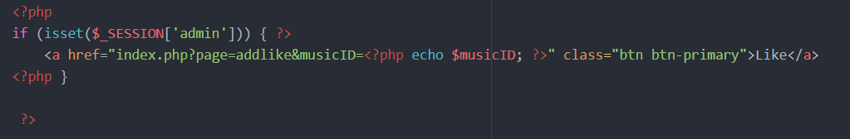

Date: 4/6/20

Student name: James

Feedback: “Just remove your search bar because it doesn’t work properly anyway”.

Changes made as a result of feedback: deleted my search bar



Date: 4/6/20

Student name: Andrie

Feedback: “you need to make it so that when you are loged in you cant see you user library”.

Changes made as a result of feedback: made it so you can only see you library when you are loged in.

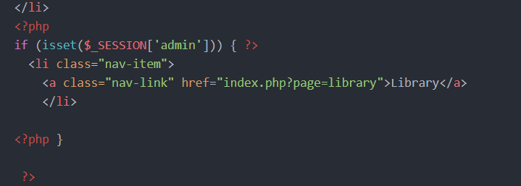

Date: 4/6/20

Student name: ethen

Feedback: make it so the like button goes away when you’re in the like page.

Changes made as a result of feedback: I made it so when your loged in and on the home page the like button appares.

